**REGIONAL VARIATION OF GDP PER HEAD WITHIN CHINA, 1080-1850: IMPLICATIONS FOR THE GREAT DIVERGENCE DEBATE**

Stephen Broadberry, Nuffield College, Oxford, [stephen.broadberry@nuffield.ox.ac.uk](mailto:stephen.broadberry@nuffield.ox.ac.uk)

Hanhui Guan, Peking University, [guanhh@pku.edu.cn](mailto:guanhh@pku.edu.cn)

15 April 2023

File: China Regions v8

*Abstract:* We examine regional variation in Chinese GDP per head for five benchmark years from the Song dynasty to the Qing. For the Ming and Qing dynasties, we provide a breakdown of regional GDP per head across seven macro regions, establishing that East Central China was the richest macro region. In addition, we provide data on the Yangzi Delta, the core of East Central China, widely seen as the richest part of China since 1400. Yangzi Delta GDP per head was 64 to 67 per cent higher than in China as a whole for three of the four Ming and Qing benchmarks, and 52 per cent higher during the late Ming. For the Northern Song dynasty, although it is not possible to derive a full regional breakdown, we provide data for Kaifeng Fu, the region containing the capital city as well as the Yangzi Delta. GDP per head in Kaifeng Fu was more than twice the level of China as a whole and higher than in the Yangzi Delta. Combined with aggregate data for GDP per head, these estimates suggest that China was the leading economy in the world during the Song dynasty and that the Great Divergence began around 1700 as the leading region of China fell decisively behind the leading region of Europe. They are also consistent with a shift in the economic centre of gravity from the north to the south between the Northern Song and Ming dynasties.

*JEL classification:* N13, N33, O10, O47

*Key words:* Great Divergence, China, regional variation, GDP per head

*Acknowledgements*: We are grateful to Markus Eberhardt, Jack Goldstone, Stephen Morgan, Ken Pomeranz, Tom Rawski, Runzhuo Zhai and participants in the Asian Historical Economics Conference, Bangkok and the New Economic History of China Conference, Northwestern University, for helpful comments and discussions. The usual disclaimer applies.

**1. INTRODUCTION**

The Great Divergence debate has highlighted the importance of comparing regions of similar size in Europe and Asia (Pomeranz, 2000; Wong, 1997; Frank, 1998; Goldstone, 2021). Since China had a much larger population than any individual European state throughout the second millennium, and European data are only available for a subset of relatively small nations, the timing of the Great Divergence cannot be settled by comparing the whole of China with Europe’s most developed nations. Broadberry, Guan and Li (2018; 2021) argue that although China as a whole was substantially poorer than the most developed European nations by the beginning of the fifteenth century, the Yangzi Delta, China’s most developed region, only fell behind around 1700, somewhat earlier than suggested by Pomeranz, but also a lot later than usually assumed by economic historians of Europe (Weber, 1930; Landes, 1969; 1998).

However, the evidence for this is indirect, since Broadberry, Guan and Li estimate a time series of GDP per head for China as a whole, and project it back from a benchmark comparison of GDP per head in the Yangzi Delta, obtained from Li and van Zanden’s (2012) comparison between the Yangzi Delta and the Netherlands in the 1820s. This effectively holds constant the ratio between GDP per head in China’s richest region and the empire as a whole. This paper tests the validity of that assumption by examining the cross-sectional distribution of GDP per head in five benchmark years from the Song dynasty to the Qing. For the Ming and Qing dynasties, data are provided for seven macro regions of China, built up from detailed provincial and prefectural data. In addition, we track the position of the Yangzi Delta, the core of East Central China, which has generally been seen as the richest part of China during this period, and broadly comparable in size to individual European nations (Pomeranz, 2000; Li, 1998; Xu et al., 2018). We find that East Central China was the richest macro region during the Ming and Qing dynasties and that the Yangzi Delta, the core of this region, was the richest part of China during the Ming and Qing dynasties. Yangzi Delta GDP per head was 64 to 67 percent higher than in China as a whole at the beginning of the Ming dynasty and again in the mid- and late Qing dynasty, and was still 52 per cent higher in the late Ming dynasty. These findings are broadly consistent with Broadberry, Guan and Li’s (2021) projection of a 75 per cent Yangzi Delta lead back from the 1820s to the early Ming dynasty as representative of the level of GDP per head in the leading Chinese region, and thus add further support to their claim that the Great Divergence began around 1700. In addition, for the Northern Song dynasty, we provide data for Kaifeng Fu, the region surrounding the capital city, which was more than twice as rich as China as a whole. This is consistent with a shift in the economic centre of gravity within China from the north to the south between the Northern Song and Ming dynasties. The high level also suggests that China was the richest economy in the world during the Song dynasty.

The paper is organised as follows. We begin in section 2 by defining the seven macro regions and setting out how they have been created from the changing structure of provinces and prefectures. We also discuss here the relationship of the Yangzi Delta to the East Central region. Section 3 then sets out the sources of the regional data and the methods used to examine regional variation in population, the production of agricultural goods and the provision of non-agricultural goods and services in each of the benchmark years. Sections 4 to 6 provide the results for the regional variation of population, agriculture and non-agricultural output per head, respectively, during the Ming and Qing dynasties while section 7 combines them into an overall evaluation of the regional variation in GDP per head. Section 8 provides evidence on GDP per head in Kaifeng Fu and the Yangzi Delta during the Northern Song dynasty, while section 9 draws out the implications for the Great Divergence debate. Section 10 concludes. The underlying regional data used to reconstruct agricultural and non-agricultural production in the benchmark years are provided in the Appendix.

**2. DEFINING CHINA’S REGIONS**

We have adopted a regional classification scheme to deal with both the expansion of Chinese territory over time and the changing administrative units as boundaries of provinces and prefectures have altered. Our solution is very similar to that of Perkins (1969: 229, 236), who worked with six macro regions during the Song dynasty and seven during the Ming and Qing dynasties.[1] For the Song dynasty, the six macro regions are North, Northwest, East Central, Central, Southeast and Southwest China. The rest of the mapped territory in Figure 1A consists of “Other States” not yet under Chinese control. For the Ming dynasty in Figure 1B, we have added “Other Territories” as a seventh macro region, which combines new lands acquired largely in the northeast and west of China. Note, however, that the more significant territorial acquisitions at this time were attached to existing administrative units, so that the Northern, Northwestern and Southwestern macro regions increased in size.[2] For the Qing dynasty in Figure 1C, the Other Territories expanded to include the whole of the mapped area, so that there are no longer any Other States.

The major administrative reorganisations in the regional structure of China from the Song to the Ming and Qing dynasties are set out in Tables 1 and 2. The largest regional administrative unit was the Province, the middle level was the Prefecture and the lowest level the County. The largest unit was known as the *Lu* during the Song dynasty, the *Buzhengsi* during the Ming and the *Sheng* during the Qing dynasty. Table 1 shows the relationship between our seven macro regions and the provinces that existed during the Song, Ming and Qing dynasties, while Table 2 shows how the prefectures in each *Lu* during the Song dynasty were reconstituted as the changed distribution of prefectures in the *Buzhengsi* of the Ming and the *Sheng* of the Qing. For example, of the 33 prefectures of Shaanxi Lu during the Song, 29 were included in the Shaanxi *Buzhengsi* of the Ming dynasty, with the other 4 being split evenly between Henan and Shanxi. However, the reallocation of these same 33 prefectures was more extensive in moving from the Ming *Buzhengsi* to the Qing *Sheng*, as the 29 Shaanxi prefectures were split between 14 in the Qing Shaanxi province and 15 in Gansu.

One issue with this classification is that the East Central region contains between a quarter and a third of the Chinese population and remains very large compared to any European nation. Furthermore, the Great Divergence literature has focused on the Yangzi Delta, which accounts for around one-third of the population of East Central China, encompassing nine Qing prefectures centred on Taihu Lake, covering parts of the three provinces of southern Jiangsu, southern Anhui and northern Zheijiang[3]. We thus include in our analysis the Yangzi Delta as a sub-region of East Central China, which provides an appropriate unit for comparison with the leading nations of Europe. The Yangzi Delta is shown in Map A of Figure 2, which also includes Map B of Kaifeng Fu. The term Fu is usually translated as superior prefecture, and during the Northern Song, Kaifeng Fu contained the capital city, Kaifeng, which has been widely seen as the richest part of China at this time (Cheng, 1992: 328; Jia, 2002; Shi, 1986: 21). Although we have been unable to reconstruct the full regional distribution of income across regions in 1080, we have been able to estimate GDP per head in Kaifeng Fu and the Yangzi delta relative to China as a whole, which provides an indication of GDP per head in the leading Chinese region before the rise to economic leadership of the Yangzi Delta as the economic centre of gravity within China shifted from the north to the south.

**3. DATA SOURCES AND METHODS**

Our basic approach is to obtain information on the regional distribution of output per head in the agricultural and non-agricultural sectors of the economy and aggregate them into a regional distribution of GDP per head. We therefore require data on the regional distribution of population as well as the main sectors of the economy. For agriculture, we need information on the cultivated land area and grain yields, while for non-agriculture we use data on the urbanisation rate by region. Since we have been unable to obtain a full regional distribution of income across all macro regions for the Northern Song dynasty, we will concentrate in sections 3 to 7 on the Ming and Qing dynasties. The cases of Kaifeng Fu and the Yangzi delta during the Northern Song dynasty will be considered in section 8.

**3.1 Population**

For the early Ming dynasty, our starting point is the detailed provincial population data provided by Cao (2000) for 1393. Cao also provided data on provincial population growth rates, which can be used to project the regional distribution of population forward to 1400. For the late Ming dynasty, we use Cao’s (2000) provincial population growth rates to project the 1393 estimates forward to 1580. In addition, Cao (2000) provides a regional breakdown of population for all provinces in 1630. For the Qing dynasty, Cao (2001) provides estimates of the regional distribution of population for 1766 and 1851. The 1766 estimates are used for the mid-Qing period (circa 1770), while the 1851 estimates are used for the late Qing period (circa 1850). More detail on sources is given in the Appendix Tables A1 to A4, together with the underlying data.

**3.2 Cultivated land**

Our estimates of the cultivated land area during the Ming dynasty are based on *Da Ming huidian*, which provides data for 1393, 1502 and 1578. We follow Perkins (1969: 229) in using the 1393 and 1502 data to reconstruct the regional distribution for the early Ming period (circa 1400). The use of the 1502 estimates in reconstructing the cultivated land area in 1400 makes sense because they rely heavily on the more systematic 1398 national survey. For the late Ming period, Chao (1986: 84) provides some estimates for the cultivated land area in 1580, starting from *Da Ming huidian*. However, Chao’s estimates are not consistent with Shi’s (2017) estimates for 1661, which also take account of the late Ming data. In particular, Chao assigns far too much land to Southwestern China, which would result in extraordinarily high agricultural output per head in a region which clearly exhibited signs of over-population in the late sixteenth century as a hostile environment, techniques of food cultivation and tools limited the cultivation of inferior soils (Lee, 1982: 717). The proportional distribution of land across regions in 1580 is therefore better represented by Shi’s (2017) regional distribution in 1661. These proportions are thus applied to the total cultivated land area in 1580 from Broadberry, Guan and Li (2021), for consistency with the macro analysis in our previous work.

Shi (2017: 57-58) also provides cultivated land data at provincial level for a number of other benchmark years in the Qing dynasty besides 1661. However, since provincial data for population are available only for a more restricted set of years, we focus here on the estimates for 1766 and 1850. More detail on sources is given in the Appendix Tables A1 to A4, together with the underlying data.

**3.3 Grain yields**

Historical grain yields have been collected by Perkins (1969: 315-332), but for the Ming dynasty he finds just 87 observations with limited geographical coverage. They have since been supplemented by Guo (2000: 375-380) with an additional 92 data points but the coverage remains relatively thin and cannot possibly be used to construct a regional distribution of grain yields.

For the Qing dynasty, by contrast, a far more representative picture of the regional variation in grain yields can be obtained from the work of Shi (2017: 218-424), who presents data on 3,000 grain yields assembled from local gazetteers and private historical sources covering a wide geographical spread. This represents a considerable increase over the 497 observations reported by Perkins (1969: 315-332) for the Qing period, and this much larger sample is sufficient to provide a full set of comparative regional grain yields. Since this variation is largely the result of underlying geographical conditions, we also use it to capture the regional distribution of grain yields in the Ming dynasty. The underlying regional data on grain yields are set out in the Appendix Table A6.

**3.4 Urbanisation**

There is little consensus about the urbanisation rate in China during the Ming dynasty, partly as a result of different definitions of urbanisation. Whereas Rozman (1973) puts the urbanisation rate at 6.5 per cent, Cao (2000) suggests a rate of 19 per cent. Rozman’s low ratio is based on an urban network of cities in China’s imperial administration, including the large national capital with around one million inhabitants and the provincial capitals with more than 3,000 inhabitants. He includes only half of the smaller prefectural capitals with an average population of 1,000 inhabitants and excludes altogether the county capitals, which he sees as more rural than urban (see also Maddison, 1998: 33-35). Cao (2000), by contrast, includes a much wider range of urban settlements. We use Cao’s study as it is the only one to provide a provincial breakdown of the urbanisation rate, and it is the urbanisation rate in each region relative to the national average that we are interested in for this paper, rather than the absolute level of the overall urbanisation rate. Cao (2000) provides regional urbanisation rates for both the early and late Ming periods in 1391 and 1630, respectively. For the Qing period, Cao (2001: 828-829) provides a provincial breakdown of the urbanisation rates for 1776 and 1893, which we use for the early and late Qing periods, respectively. Data for the urbanisation rate in the Yangzi Delta during the same years are taken from Xu et al. (2018: 346). Regional urbanisation rates by province are shown in the Appendix Table A7.

**4. REGIONAL POPULATION SHARES**

Part A of Table 3 sets out the shares of population in each region for the four benchmark years of 1400 and 1580 during the Ming and 1770 and 1850 during the Qing dynasty, based on the more disaggregated provincial data in the Appendix Tables A2 to A5. Part B of Table 3 provides the absolute population levels in millions, setting the total Chinese population in each benchmark year to be consistent with the estimates in Broadberry, Guan and Li (2021). A number of conclusions can be drawn. First, it is clear that the two most populous regions during the Ming and the Qing have been Northern and East Central China, together accounting for between 50 and 60 per cent of the total Chinese population. Second, although the Chinese Empire acquired vast amounts of territory, particularly during its expansion at the beginning of the Qing dynasty, these other territories remained sparsely populated and therefore had little impact on the regional distribution of the population. Third, however, note that the East Central region saw its share of the total population decline from an early Ming peak of a little over one-third to just over a quarter by the late Qing period. Fourth, mirroring the decrease in the East Central region’s share, Southwestern China saw its share of the population increase substantially over time from under 5 per cent to nearly 12 per cent and the share of Northwestern China also increased.

**5. AGRICULTURAL OUTPUT PER HEAD**

In this section we examine the regional distribution of agricultural output per head for the benchmark years. We begin by setting out in part A of Table 4 the share of cultivated land in each region, again derived from the provincial data shown in the Appendix Tables A2 to A5. The level of cultivated land per head for each region relative to the average for China is then derived in part B of Table 4 by comparing the share of cultivated land in each region (from part A of Table 4) with the share of population in each region (from part A of Table 3). A striking finding from this table is that the land-labour ratio was much more favourable in the dry farming regions of the North and Northwest throughout the period, and also in the sparsely populated Other Territories during the Qing. We have assumed that the land-labour ratio in the Yangzi Delta was the same as in the rest of East Central China.

However, these patterns in the land-labour ratio were offset by regional variation in grain yields, set out in Table 5. Grain yield data during the Ming dynasty are insufficient to capture regional variation, so we make use of the regional pattern of grain yields established by Shi (2017) using 3,000 observations from the Qing dynasty.[4] The highest average yields were in the East Central region, and the micro evidence reveals a pattern of higher yields in the southern provinces compared with the northern provinces and also higher yields in the east than in the west. We have assumed that grain yields in the Yangzi Delta were the same as in the rest of East Central China.

We are thus able in Table 6 to present estimates of agricultural output per head for each region relative to the average for China as a whole by combining the information on grain yields from Table 5 with the data on land per head relative to the China average from part B of Table 4. Note that the high levels of cultivated land per head in the north and northwest did not translate into high levels of agricultural output per head because of the much lower grain yields in dry farming. By contrast, East Central China remained above average in terms of agricultural output per head throughout the entire period as a result of high grain yields in paddy farming, although other southern regions did even better during both the Ming and Qing dynasties. As already indicated, we have not attempted to provide estimates for agricultural output per head in the Yangzi Delta that are different from the rest of the East Central region, as we lack sufficient detailed information at this level and the Yangzi Delta’s high income per head is usually ascribed to the performance of its non-agricultural sectors, to which we now turn.

**6. NON-AGRICULTURAL OUTPUT PER HEAD**

In European economic history, it has become standard practice to estimate GDP per head from information on the agricultural sector together with data on the urbanisation rate to capture the output of the non-agricultural sector. This approach began with Wrigley (1985) and has recently been used to construct time series of GDP per head for a number of European countries during the early modern period (Malanima, 2011; Álvarez-Nogal and Prados de la Escosura, 2013; Schön and Krantz, 2012).

Here we adapt the method to regional variation, treating a high urbanisation rate as an indicator of prosperity in a cross-section of regions, provinces and prefectures. The results are set out in Table 7, where part A provides the urbanisation rates in each region, based on the more disaggregated provincial data in the Appendix Table A7. East Central China stands out as the most urbanised region throughout the period and the Yangzi Delta was substantially more urbanised than the rest of the East Central region. Part B of Table 7 shows the same information relative to the average rate for China as a whole. East Central China was up to 56 per cent more urbanised than the China average and the Yangzi Delta was two to three times more urbanised.

**7. GDP PER HEAD**

Table 8 combines the regional pattern of agricultural output per head from Table 6 with the data on regional urbanisation rates from part B of Table 7 to estimate GDP per head relative to China as a whole, with the urbanisation rate capturing the variation in non-agricultural output per head. The weights are 67 per cent for agriculture and 33 per cent for non-agriculture, consistent with the shares in Broadberry, Guan and Li (2021). Note that the same weights should be applied across all regions, as both the agricultural output per head and urbanisation variables have been measured relative to the China average.

A number of results stand out. First, GDP per head was generally higher in the south than in the north. This follows from the high weight of agriculture together with the higher grain yields in the south. Second, GDP per head was consistently higher in the East Central region than in China as a whole. Third, the core region of the Yangzi Delta had a GDP per head that was consistently higher than the rest of East Central China. Fourth, the scale of the Yangzi Delta GDP per head lead over China as a whole was 64 to 67 per cent in three of the four benchmarks, and 52 per cent higher during the late Ming.

**8. KAIFENG FU AND THE YANGZI DELTA DURING THE SONG DYNASTY**

Although we have set out some data on the regional distribution of population and cultivated land circa 1080 in Appendix Table A1, we cannot assume that the regional distribution of grain yields for the Qing and Ming dynasties applied also to the Song, because it is widely assumed in the literature that Chinese economic leadership shifted from the largely wheat-growing north to the largely rice-growing south between the Song and Ming dynasties with the diffusion of new strains of faster-ripening rice creating major changes in cropping practices and the distribution of population between the south and the north (Maddison, 1998: 24, 30-31; Cheng, 1992: 331-332). This means that we cannot establish the full regional distribution of agricultural output per head in 1080. This, together with the patchiness of data on the regional distribution of urbanisation rates at this time, prevents us from attempting a complete regional breakdown of GDP per capita during the Song dynasty. However, the capital city during the Northern Song dynasty was Kaifeng in Northern China, and we have been able to assemble data on the surrounding prefecture, Kaifeng Fu, to suggest that this was the richest region around 1080. We have also put together a rough estimate of the situation in the Yangzi Delta at this time, so as to capture the changing relative positions of the north and south.

The basic data for our Song dynasty calculations are set out in Table 9. In part A, the population data for 1080 are taken from Wu (2000), based on the number of households multiplied by the average household size. These data are also shown in the wider regional context in Table A1. The population of Kaifeng Fu was substantially smaller than the population of the Yangzi Delta, but is still comparable to the population of England in 1086, for which Darby (1977: 89) suggests a figure of 1.45 to 1.60 million. The cultivated land data are derived from the *Wenxian tongkao, Tianfu kao*, Vol.4, which gives a figure of 11.4 million mu in Kaifeng Fu, or 2.47 per cent of the land in China. Qi (2009: 65) shows that following the reform of land tax by Prime Minister Wang Anshi, 1072-1085, the true cultivated area in China was 705.3 million mu, and applying the ratio of 2.47 per cent to this area results in a revised cultivated area of 17.4 million mu. We assume that the land per capita figure of 11.1 mu for East Central China from Table A1 applies to the Yangzi Delta, as we have assumed for the Ming and Qing dynasties, which implies a cultivated land area of 63.3 million mu in 1080.

Wu (1985) provides separate estimates of wheat and rice yields, which were equal in 1080. This was before the divergence in northern and southern grain yields following the widespread diffusion of fast-ripening rice in the south. Hence we use the same grain yield in both north and south China at this time. The urbanisation rate for Kaifeng Fu is taken from Wu (2000). We have used the ratio of households in the capital city to total households in Kaifeng Fu, which yields an urbanisation rate of 37.4 per cent, compared with 12.0 per cent for China as a whole. If all small towns were included, this ratio could be increased to as much as 52.7 per cent, but we have preferred the lower figure as more realistic for an international comparative study. For the Yangzi Delta, we have taken an urbanisation rate of 25.0 per cent from Xu et al. (2018: 345).[5]

In Part B of Table 9, we estimate GDP per head in Kaifeng Fu and the Yangzi Delta relative to China average. Cultivated land per head was 79 per cent higher in Kaifeng Fu and grain yields are assumed to be equal to the Chinese average. Hence agricultural output per head in Kaifeng Fu was also 79 per cent above the national average. With the urbanisation rate in Kaifeng Fu more than three times the China average, this yields a GDP per head in Kaifeng Fu nearly two-and-a-quarter times the national average. In the Yangzi Delta, agricultural output per head and the urbanisation rate were both substantially above the national average, but not by as much as in Kaifeng Fu. Hence with a GDP per head about one-and-two-thirds the China average, the Yangzi Delta lagged behind Kaifeng Fu. This is consistent with the qualitative and quantitative evidence provided by Cheng (1992: 331-332), who argues that: (1) Kaifeng Fu had a unique economic structure with its inclusion of the capital city, was known as the centre of commerce and finance, and also had the most developed handicraft industry; (2) although the Yangzi Delta was growing faster, it was still catching up on the north at this time; (3) tax revenue per household was much higher in Kaifeng Fu than in any other region despite tax rates being the same across different regions.

**9. IMPLICATIONS FOR THE GREAT DIVERGENCE DEBATE**

Broadberry, Guan and Li (2018; 2021) provide evidence that the Yangzi Delta, widely seen as China’s richest region during the Ming and Qing dynasties, only fell behind the leading regions of Europe around 1700. However, this was based on projecting the Yangzi Delta’s 75 per cent GDP per head lead over China as a whole from the 1820s back to the early Ming dynasty. This rests on the assumption that there was always at least one Chinese region that had GDP per head that was higher than the Chinese average by the same ratio as in the 1820s. What we have shown in Table 8 is that this is a reasonable assumption for the Ming and Qing dynasties, and that the leading region was the Yangzi Delta. In addition, although we are unable to provide a complete regional breakdown during the Song dynasty, we are able in Table 9 to show that Kaifeng Fu in the northern region had GDP per head that was over twice the national average and was also significantly ahead of the Yangzi Delta, the richest southern region.

Table 10 shows GDP per head on a regional basis in 1990 international dollars. This is obtained by taking the estimates of GDP per head relative to the China average from Tables 8 and 9, and applying them to the aggregate GDP per head for China as a whole for each benchmark from Broadberry Guan and Li (2021). In interpreting these results, it is useful to bear in mind that in 1990, the World Bank’s poverty line was drawn at an income of $1 per day, which means that if everybody lived at the subsistence level, annual GDP per head would be $365. Since most societies have always had a rich elite, Maddison (1995) thought in terms of $400 as bare bones subsistence over the long run. A number of findings stand out clearly from Table 10. First, from the Ming to the Qing dynasty, the Yangzi Delta was the richest Chinese region, with GDP per head more than three times the subsistence level during the Ming dynasty and still two-and-a-half times subsistence during the Qing. Second, GDP per capita remained well above subsistence in most of central and southern China, buoyed up by the high grain yields from paddy farming. Third, however, GDP per capita was much closer to subsistence in northern and northwestern China, where dry farming resulted in low yields which were only partially offset by higher land-labour ratios than in the south. Fourth, Kaifeng Fu exhibited very high GDP per head during the Northern Song dynasty, largely as a result of very high levels of urbanisation.

Table 11 then shows GDP per head in the leading region of China in 1990 international dollars for each of the benchmark years, and compares them with the time series estimates from Broadberry, Guan and Li (2021), to assess how reasonable it was for the latter to hold constant the ratio of GDP per head in China’s richest region and the empire as a whole. During the Ming and Qing dynasties, only for 1580 is the difference more than 3 per cent. These benchmark estimates can thus be seen as broadly consistent with Broadberry, Guan and Li’s (2021) characterisation of the Great Divergence beginning around 1700, as shown in Figure 3. Before then, GDP per head in the leading regions of Europe and China remained in the same ballpark, while the Great Divergence began from around 1700 as the leading parts of Europe made the transition to continuous modern economic growth at the same time as GDP per head in the leading parts of China entered a period of decline as population expanded rapidly.

Our more speculative benchmark for the Northern Song dynasty circa 1080 suggests that GDP per head in the prefecture containing the capital city, Kaifeng Fu, was richer than China as a whole by a rather larger proportion than the Yangzi Delta. This indicates a level of GDP per head in the leading Chinese region of just over $1,931 in 1990 international prices, on a par with the highest levels reached in European nations during the late medieval and early modern periods. This therefore supports the view that Song dynasty China was the world economic leader at the time, consistent with the views of many earlier writers (Needham, 1954; Wittfogel, 1957; Hartwell, 1966 and Elvin, 1973).

**10. CONCLUSIONS**

In this paper, we examine regional variation in Chinese GDP per head and draw out the implications for the Great Divergence debate. Most work on Chinese historical national accounting focuses on obtaining estimates of GDP per head for China as a whole (Maddison, 2010; Xu et al., 2017; Ma and de Jong, 2019). However, this is not very satisfactory for establishing the timing of the Great Divergence of productivity and living standards between Europe and Asia because China was so much larger than the individual European nations for which GDP per head data are available. What is needed is systematic information on the regional variation of GDP per head within China.

For five benchmark years from the Song dynasty to the late Qing, we examine regional variation in Chinese GDP per head. For the Ming and Qing dynasties, we provide a breakdown of GDP per head across seven macro regions, establishing that East Central China was the richest macro region. In addition we delve within the East Central macro region to present estimates for the Yangzi Delta, which has often been seen as the richest Chinese region. We have shown that the Yangzi Delta was the leading Chinese region, and that Yangzi GDP per head was 64 to 67 per cent higher than in China as a whole for three of the four benchmark years and 52 per cent higher in the late Ming. For the Northern Song dynasty, we have shown that GDP per head in Kaifeng Fu was more than twice the level of China as a whole, and higher than in the Yangzi Delta. This supports the idea of a major shift in the economic centre of gravity shifted from the north to the south of China between the Northern Song and Ming dynasties

These data on regional variation in GDP per head can be combined with the aggregate data for Chinese GDP per head in 1990 international dollars and compared with GDP per head in European nations to assess the timing of the Great Divergence. This confirms the conclusion of Broadberry, Guan and Li (2018; 2021) that the Great Divergence began only around 1700 as the leading region of China fell decisively behind the leading region of Europe. It also supports the idea that China was the world economic leader in the Northern Song dynasty.

**FIGURE 1: Chinese macro regions, 1080-1850**

**A. Northern Song dynasty China, c. 1080**

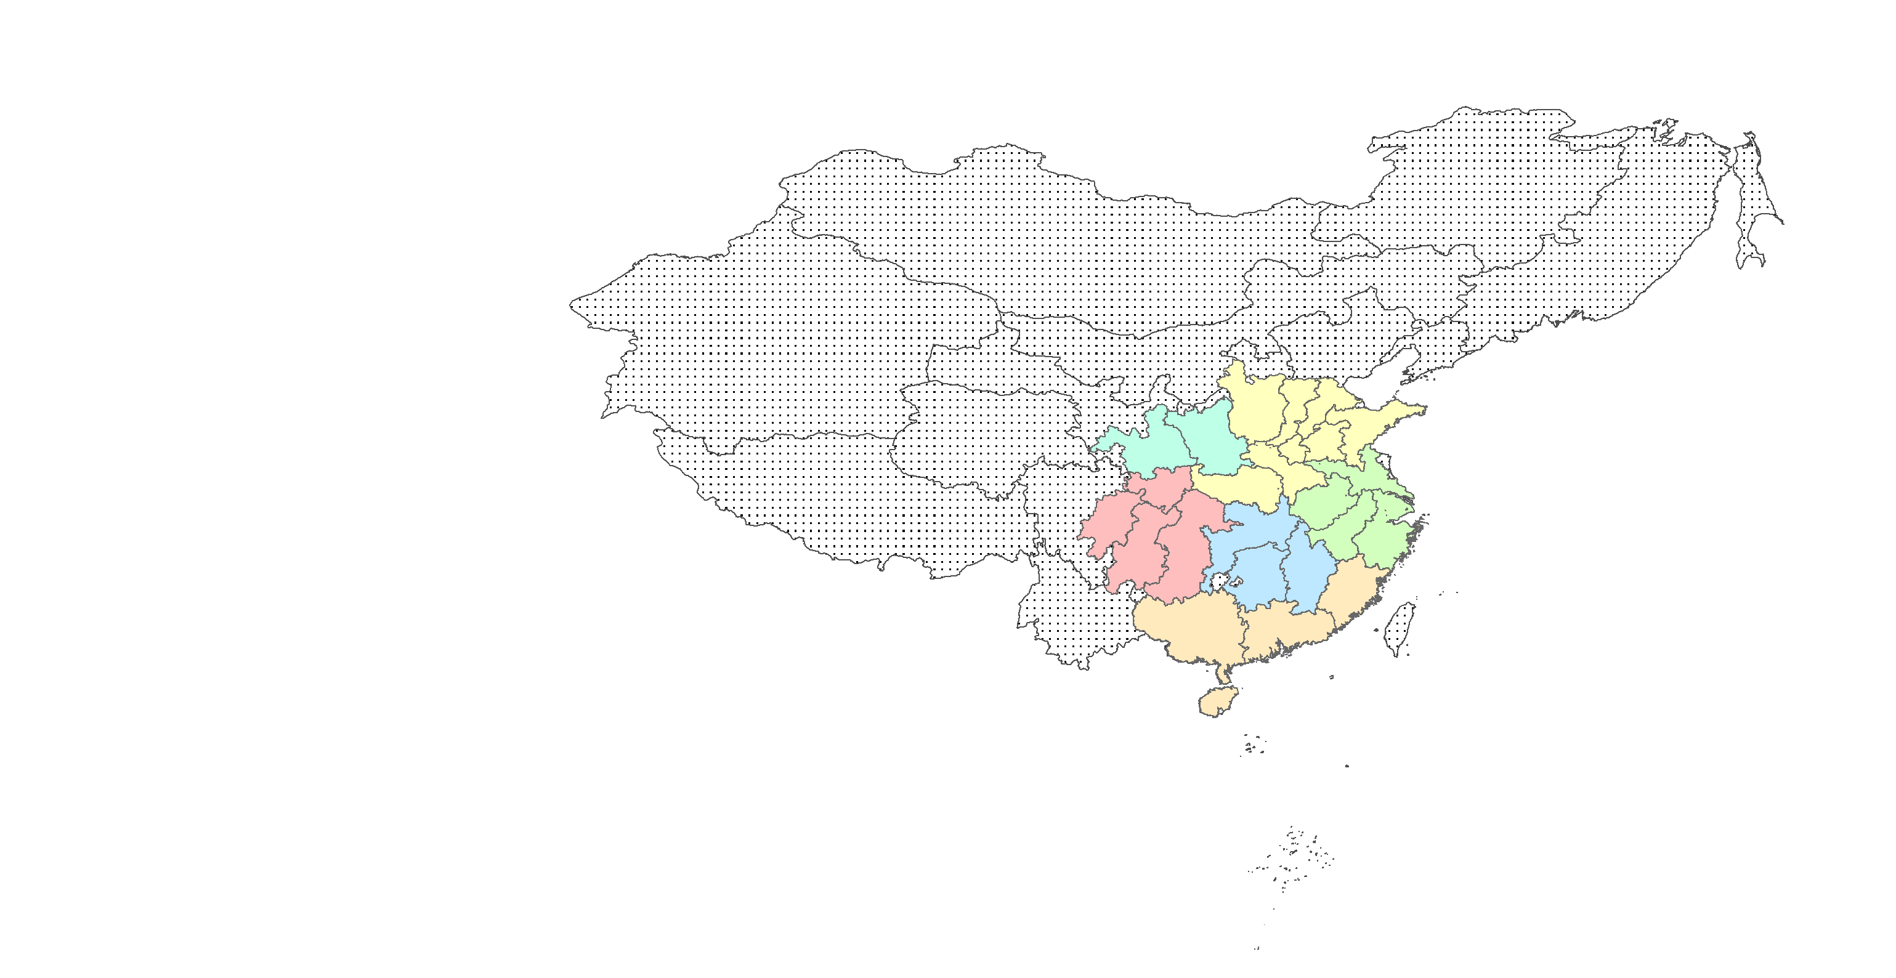

**B. Ming dynasty China c.1400**

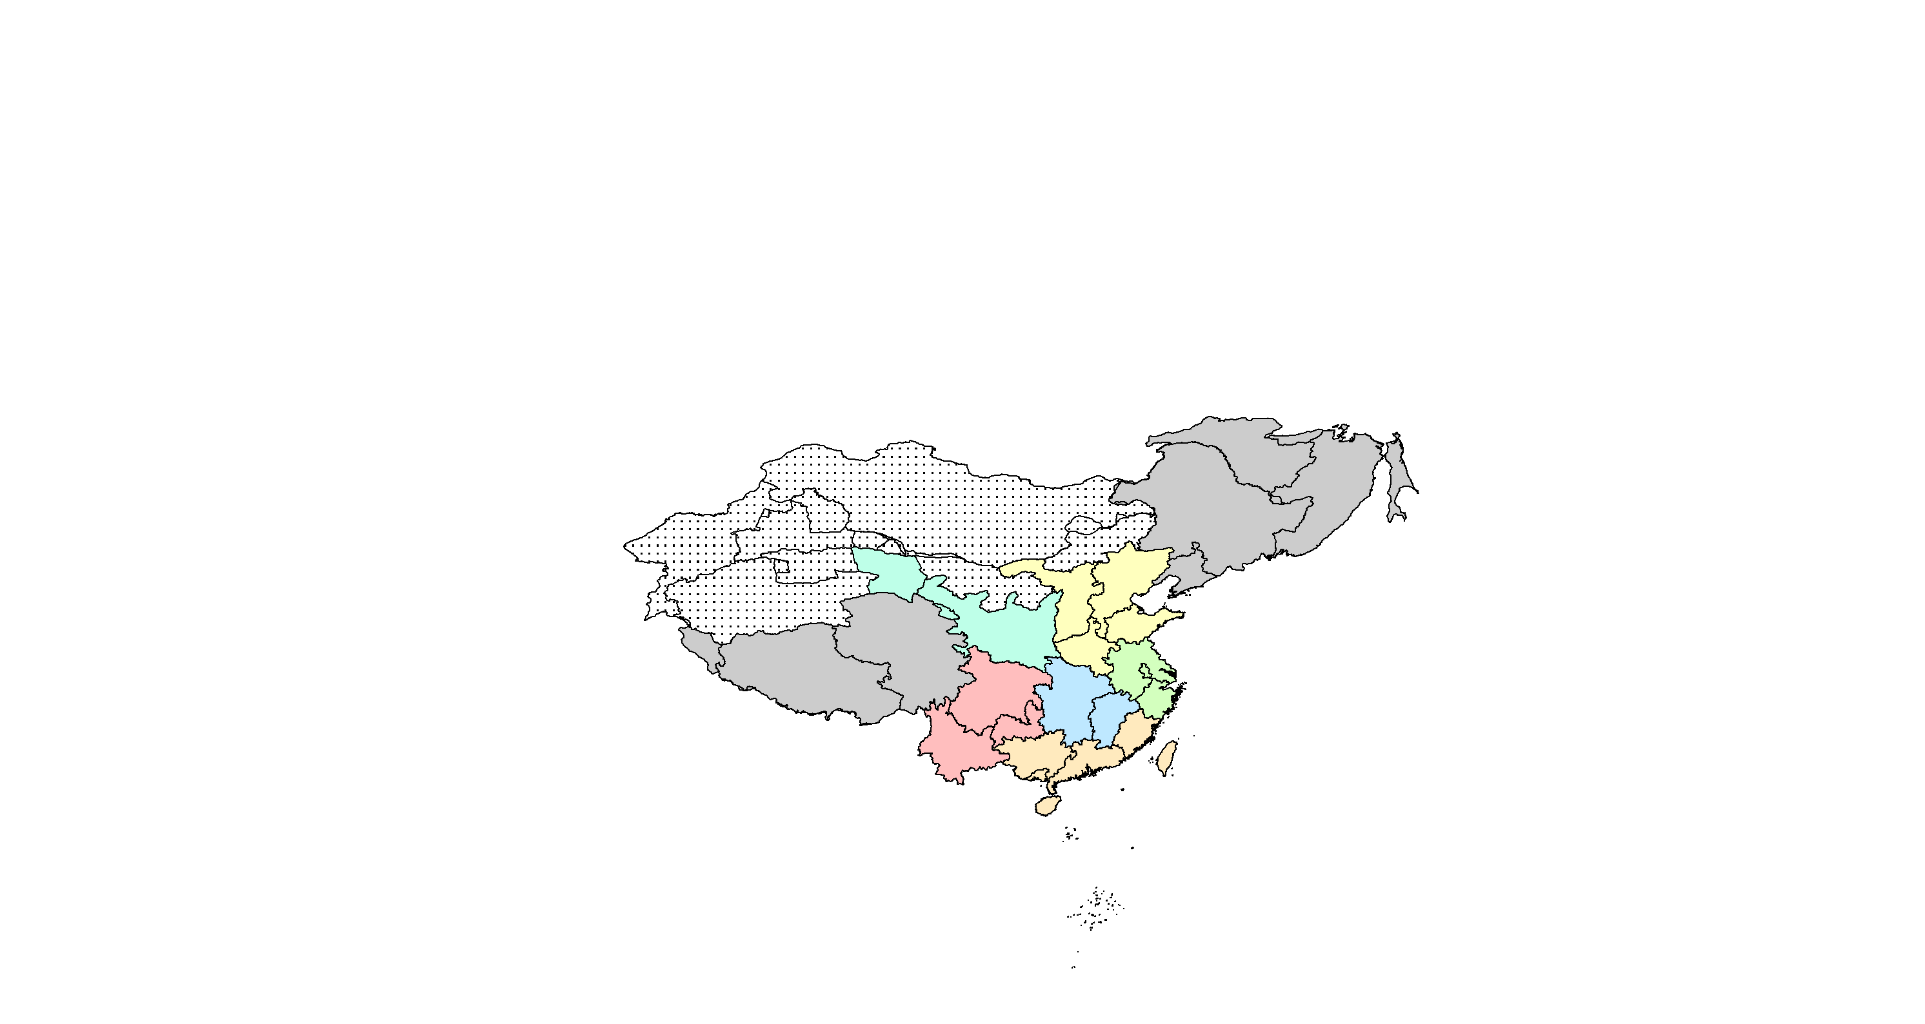

**FIGURE 1 (continued): Chinese macro regions, 1080-1850**

**C. Qing dynasty China c.1850**

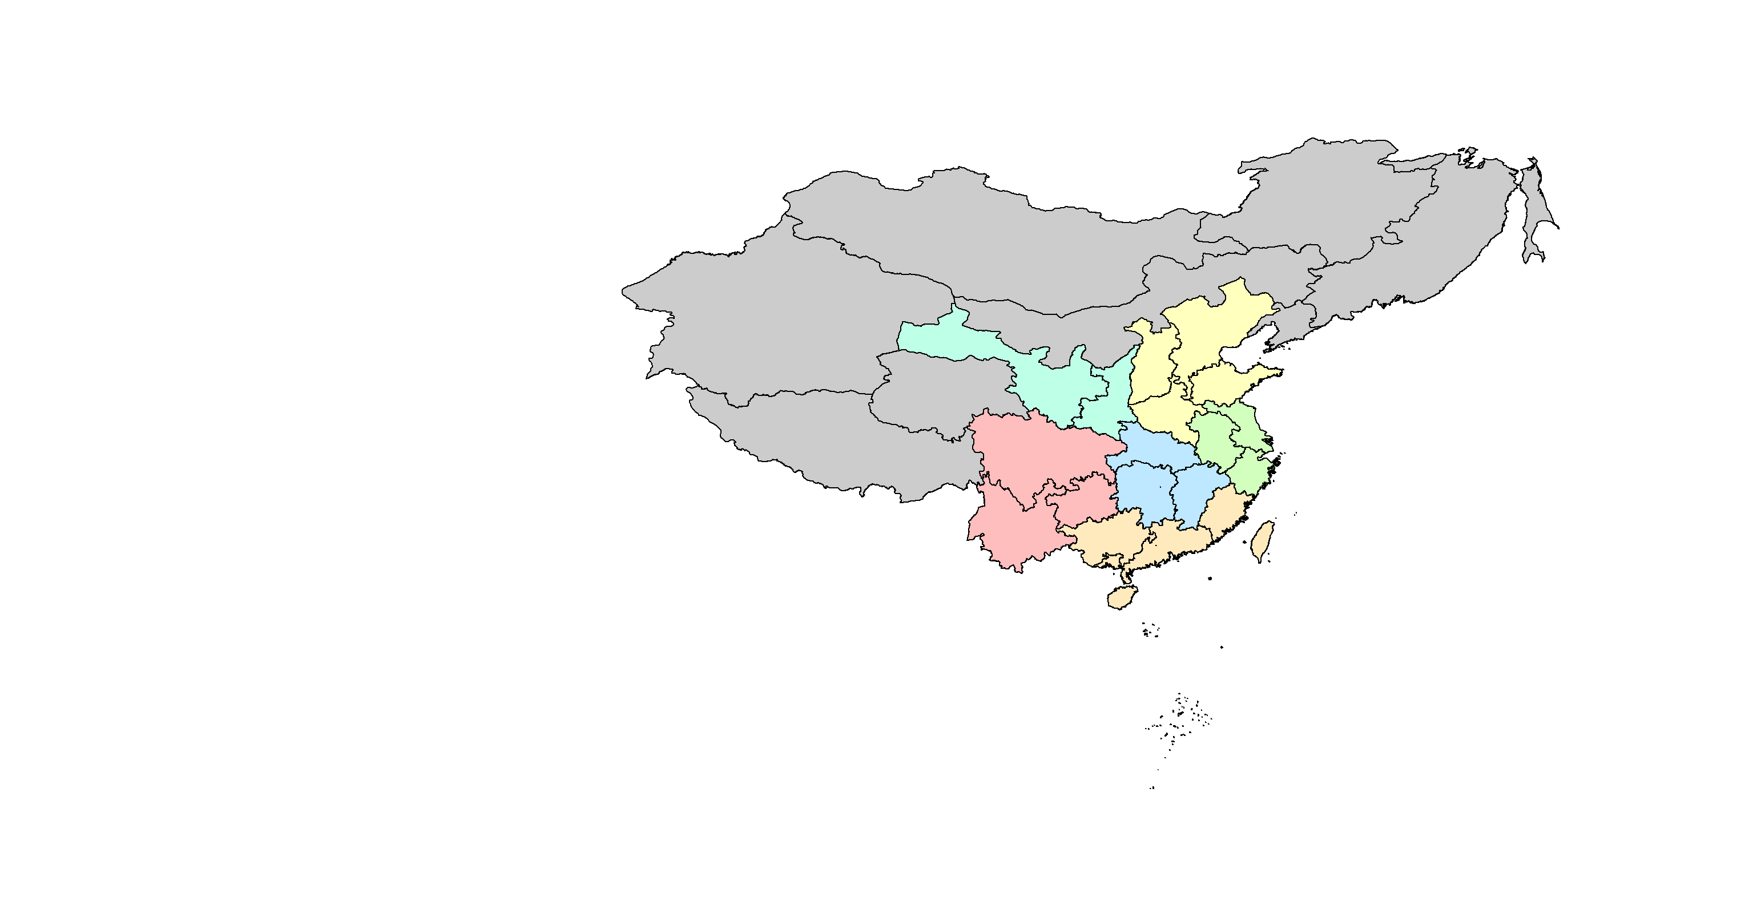

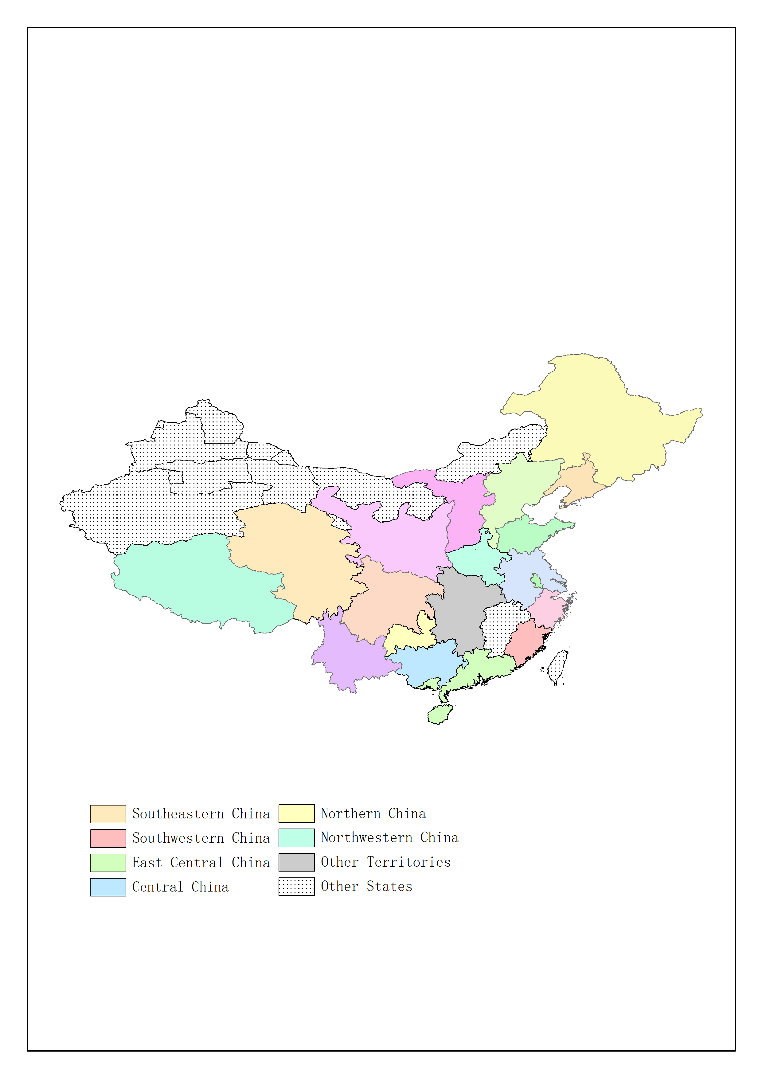

*Sources and notes:* Map A: based on 1080 territory, Map B: based on 1391 territory,

Map A and Map B obtained from Robert Hartwell’s “China Historical Studies” GIS dataset (<http://www.people.fas.harvard.edu/~chgis/data/hartwell/>).

Map C: based on 1820 territory, obtained from the China Historical Geographical Information System (<http://www.people.fas.harvard.edu/~chgis/>).

**FIGURE 2: Chinese sub-regions: the Yangzi Delta and Kaifeng Fu**

**A. Yangzi Delta**

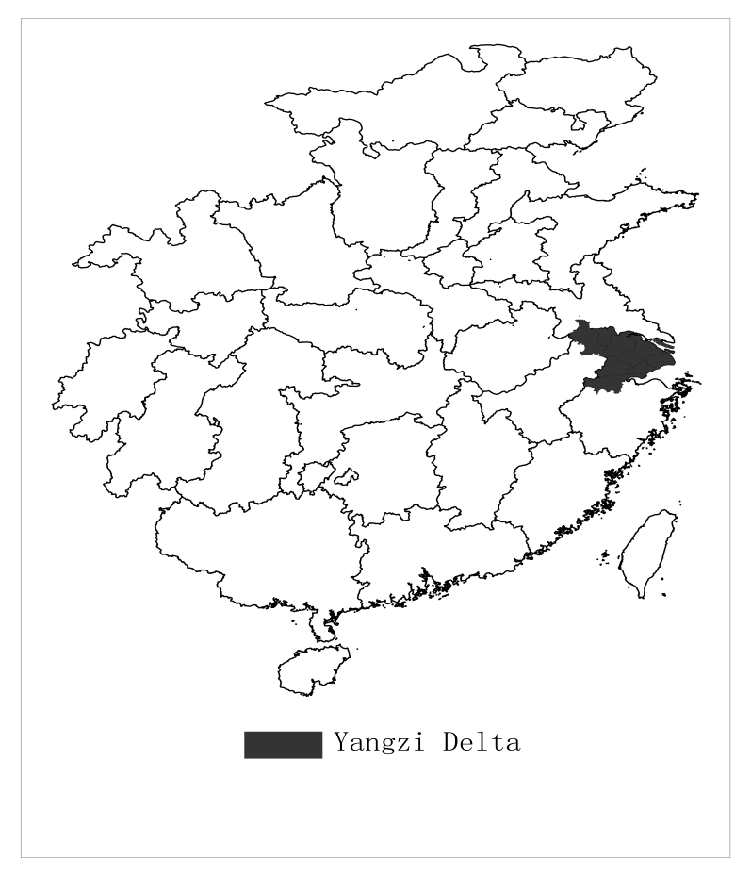

**B. Kaifeng Fu**

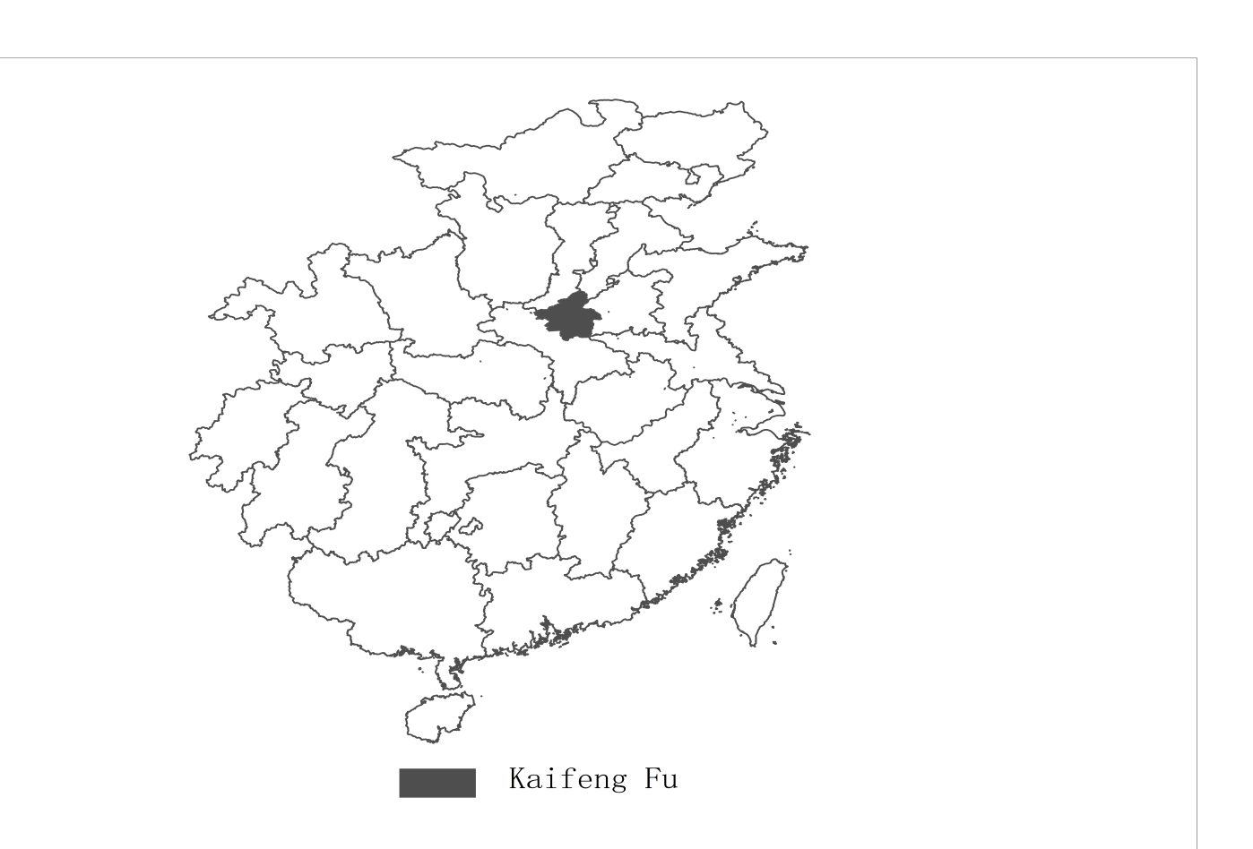

*Sources and notes:* Map A: Yangzi Delta includes 9 core prefectures: Jiangning, Zhenjiang, Suzhou, Changzhou, Songjiang, Hangzhou, Huzhou, Jiaxing and Taicang Zhou.

Map B: Kaifeng Fu based on 1080 territory, obtained from Robert Hartwell’s “China Historical Studies” GIS dataset.

**FIGURE 3: GDP per head in the leading regions of Europe and China, 1300-1850 (1990 international dollars)**

Sources and notes: Broadberry, Guan and Li (2021). Europe leader is Italy 1300-1540, Netherlands 1540-1800 and Britain 1800-1850. China leader is obtained by projecting back from the 1820 level of GDP per head in the Yangzi Delta derived from Li and van Zanden (2012) using the series for GDP per head in China as a whole.

**TABLE 1: Chinese Regions in the Song, Ming and Qing Dynasties**

|  |  |  |  |
| --- | --- | --- | --- |
|  | Song  (Lu) | Ming  (Buzhengsi) | Qing  (Sheng) |
| Northwestern China | Shaanxi Lu | Shaanxi | Shaanxi,  Gansu |
| Northern China | Kaifeng Fu,  Jingxi Lu,  Hedong Lu,  Jingdong Lu,  Hebei Lu | Henan,  Shanxi,  Shandong,  Jingshi | Henan,  Shanxi,  Shandong,  Zhili |
| East Central China | Huainan Lu,  Jiangnan Dong Lu,  Liangzhe Lu | Nanjing  (Anhui+Jiangsu),  Zhejiang | Anhui,  Jiangsu,  Zhejiang |
| Central China | Jinghu Bei Lu,  Jinghu Nan Lu,  Jiangnan Xi Lu | Huguang  (Hubei +Hunan),  Jiangxi | Hubei,  Hunan,  Jiangxi |
| Southeastern China | Guangnan Xi Lu,  Guangnan Dong Lu,  Fujian Lu | Guangxi,  Guangdong,  Fujian | Guangxi,  Guangdong,  Fujian |
| Southwestern China | Chengdu Lu,  Zizhou Lu,  Lizhou Lu,  Kuizhou Lu | Sichuan,  Guizhou,  Yunnan | Sichuan,  Guizhou,  Yunnan |
| Other Territories | n.a. | Heilongjiang,  Jilin,  Liaoning,  Qinghai,  Tibet | Heilongjiang,  Jilin,  Liaoning,  Xinjiang,  Qinghai,  Tibet,  Inner Mongolia,  Taiwan |

Sources and notes: Li (2007), Guo and Jin (2007), Fu et al. (2013).

For the Song dynasty, the Lu listed here are for 1020. By 1080, the year mapped in Figure 1A, some Lu had been divided into two parts. In Northwest China, Shaanxi Lu was divided into Yongxingjun Lu and Qinfeng Lu. In North China, Jingxi Lu was divided into Jingxinan (Southern Jingxi) Lu and Jingxibei (Northern Jingxi) Lu; Jingdong Lu was divided into Jingdongdong (Eastern Jingdong) Lu and Jingdongxi (Western Jingdong) Lu; Hebei Lu was divided into Hebeidong (Eastern Hebei) Lu and Hebeixi (Western Hebei) Lu. In East Central China, Huainan Lu was divided into Huainandong (Eastern Huainan) Lu and Huainanxi (Western Huainan) Lu.

The additional territory of the Ming Dynasty included Nuergan Dusi and Liaodong Dusi in the northeast, which roughly covered Heilongjiang, Jilin and Liaoning in the Qing Dynasty. It also included the Uszang Dusi and the Duogan Dusi in the southwest, which roughly covered Qinghai and Tibet in the Qing Dynasty.

After the Qing unified the whole of China, they established Hunan and Hubei provinces from Huguang Buzhengsi, established Anhui and Jiangsu Sheng from Nanjing, established Gansu Sheng from Shaanxi Buzhengsi, so there are 18 provinces in total in Qing China which once were governed by Han ethnicity in Ming China. The data in this paper covered all these 18 provinces.

**TABLE 2: The distribution of prefectures from Song to Ming and Qing**

|  |  |  |
| --- | --- | --- |
| Song  (Lu) | Ming  (Buzhengsi) | Qing  (Sheng) |
| Shaanxi Lu (33) | Henan (2), Shanxi(2), Shaanxi (29) | Henan (2), Shanxi (2), Shaanxi (14), Gansu (15) |
| Kaifeng Fu (1) | Henan (1) | Henan (1) |
| Jingxi Lu (16) | Henan (9), Huguang (5), Nanjing (1), Shaanxi (1) | Henan (9), Hubei (5) Anhui (1) Shaanxi (1) |
| Hedong Lu (21) | Shanxi (19), Shaanxi (2) | Shanxi (19), Shaanxi (2) |
| Jingdong Lu (17) | Shandong (14), Nanjing (3) | Shandong (14), Jiangsu (3) |
| Hebei Lu (33) | Jingshi (26), Henan (3), Shandong (4) | Zhili (26), Henan (3), Shandong (4) |
| Huainan Lu (19) | Henan (1), Huguang (2), Nanjing (16) | Henan (1), Hubei (2), Jiangsu (6), Anhui (10) |
| Jiangnan Dong Lu (10) | Nanjing (6), Jiangxi (4) | Anhui (5), Jiangsu (1), Jiangxi (4) |
| Liangzhe Lu (14) | Nanjing (3), Zhejiang (11) | Jiangsu (3), Zhejiang (11) |
| Jinghu Bei Lu (8) | Huguang (8) | Guangxi (1), Hunan (7) |
| Jinghu Nan Lu (10) | Huguang (10) | Hubei (5), Hunan (5) |
| Jiangnan Xi Lu (10) | Huguang (1), Jiangxi (9) | Hubei (1), Jiangxi (9) |
| Guangnan Xi Lu (26) | Guangxi (19) Guangdong (7) | Guangxi (19), Guangdong (7) |
| Guangnan Dong Lu (14) | Guangxi (1), Guangdong (13) | Guangxi (1), Guangdong (13) |
| Fujian Lu (8) | Fujian (8) | Fujian (8) |
| Chengdu Lu (14) | Sichuan (14) | Sichuan (14) |
| Zizhou Lu (14) | Sichuan (14) | Sichuan (14) |
| Lizhou Lu (12) | Sichuan (7) Shaanxi (5) | Sichuan (7), Shaanxi (2), Gansu (3) |
| Kuizhou Lu (13) | Sichuan (13) | Sichuan (13) |

Sources and notes: Li (2007), Guo and Jin (2007), Fu et al. (2013).

**TABLE 3: Regional distribution of population, 1400-1850**

**A. Share of population in each region (%)**

|  |  |  |  |  |
| --- | --- | --- | --- | --- |
|  | 1400 | 1580 | 1770 | 1850 |
| NORTHWESTERN CHINA | 4.3 | 5.1 | 7.6 | 7.4 |
| NORTHERN CHINA | 24.1 | 27.5 | 26.0 | 25.0 |
| Yangzi Delta | 12.1 | 12.1 | 8.6 | 8.7 |
| EAST CENTRAL CHINA | 34.3 | 31.7 | 25.9 | 25.8 |
| CENTRAL CHINA | 18.8 | 19.2 | 16.1 | 15.7 |
| SOUTHEASTERN CHINA | 13.5 | 11.5 | 12.8 | 12.2 |
| SOUTHWESTERN CHINA | 4.9 | 5.1 | 9.8 | 11.7 |
| OTHER TERRITORIES |  |  | 1.8 | 2.2 |
| CHINA | 100.0 | 100.0 | 100.0 | 100.0 |

**B. Number of people in each region (millions)**

|  |  |  |  |  |
| --- | --- | --- | --- | --- |
|  | 1400 | 1580 | 1770 | 1850 |
| NORTHWESTERN CHINA | 3.1 | 8.2 | 22.1 | 30.5 |
| NORTHERN CHINA | 17.3 | 44.5 | 75.5 | 103.2 |
| Yangzi Delta | 8.7 | 19.6 | 24.8 | 36.0 |
| EAST CENTRAL CHINA | 24.6 | 51.4 | 75.1 | 106.2 |
| CENTRAL CHINA | 13.5 | 31.1 | 46.7 | 64.5 |
| SOUTHEASTERN CHINA | 9.7 | 18.6 | 37.1 | 50.3 |
| SOUTHWESTERN CHINA | 3.5 | 8.2 | 28.3 | 48.1 |
| OTHER TERRITORIES |  |  | 5.1 | 9.2 |
| CHINA | 71.7 | 162.0 | 289.9 | 412.0 |

Sources and notes: Regional population shares for 1400 from Perkins (1969). For 1580 from Perkins (1969) adjusted using growth rates from Cao (2000). For 1770 and 1850 from Cao (2001). Total population for China in all benchmark years from Broadberry, Guan and Li (2018).

**TABLE 4: Regional distribution of cultivated land, 1400-1850**

**A. Share of cultivated land in each region (%)**

|  |  |  |  |  |
| --- | --- | --- | --- | --- |
|  | 1400 | 1580 | 1770 | 1850 |
| NORTHWESTERN CHINA | 6.1 | 6.8 | 9.0 | 10.3 |
| NORTHERN CHINA | 34.7 | 42.0 | 39.9 | 34.6 |
| EAST CENTRAL CHINA | 30.1 | 24.6 | 17.9 | 16.6 |
| CENTRAL CHINA | 15.2 | 14.6 | 13.1 | 12.1 |
| SOUTHEASTERN CHINA | 11.3 | 9.1 | 8.3 | 8.0 |
| SOUTHWESTERN CHINA | 2.5 | 3.0 | 7.9 | 9.4 |
| OTHER TERRITORIES |  |  | 3.9 | 9.0 |
| CHINA | 100.0 | 100.0 | 100.0 | 100.0 |

**B. Land per head relative to China average (China=100)**

|  |  |  |  |  |
| --- | --- | --- | --- | --- |
|  | 1400 | 1580 | 1770 | 1850 |
| NORTHWESTERN CHINA | 141.7 | 134.7 | 117.9 | 139.1 |
| NORTHERN CHINA | 143.9 | 152.9 | 153.2 | 138.0 |
| Yangzi Delta | 87.7 | 77.5 | 69.2 | 64.3 |
| EAST CENTRAL CHINA | 87.7 | 77.5 | 69.2 | 64.3 |
| CENTRAL CHINA | 81.0 | 75.9 | 81.6 | 77.2 |
| SOUTHEASTERN CHINA | 83.3 | 79.0 | 64.5 | 65.8 |
| SOUTHWESTERN CHINA | 51.7 | 58.3 | 81.1 | 80.6 |
| OTHER TERRITORIES |  |  | 219.0 | 403.6 |
| CHINA | 100.0 | 100.0 | 100.0 | 100.0 |

Sources and notes: See the Appendix Tables A1 to A4. Land per head in Yangzi Delta assumed to be equal to the average for East Central China.

**TABLE 5: Regional variation in grain yields**

|  |  |
| --- | --- |
|  | Grain yield  (China=100) |
| NORTHWESTERN CHINA | 46.7 |
| NORTHERN CHINA | 34.6 |
| Yangzi Delta | 172.0 |
| EAST CENTRAL CHINA | 172.0 |
| CENTRAL CHINA | 151.1 |
| SOUTHEASTERN CHINA | 211.5 |
| SOUTHWESTERN CHINA | 162.1 |
| OTHER TERRITORIES | 33.0 |
| CHINA | 100.0 |

Sources and notes: Derived from Shi (2017: 218-424). Grain yields in Yangzi Delta assumed to be equal to the average for East Central China.

**TABLE 6: Agricultural output per head relative to China average, 1400-1850 (China=100)**

|  |  |  |  |  |
| --- | --- | --- | --- | --- |
|  | 1400 | 1580 | 1770 | 1850 |
| NORTHWESTERN CHINA | 66.2 | 62.9 | 55.1 | 65.0 |
| NORTHERN CHINA | 49.8 | 52.9 | 53.0 | 47.8 |
| Yangzi Delta | 150.9 | 133.3 | 119.1 | 110.6 |
| EAST CENTRAL CHINA | 150.9 | 133.3 | 119.1 | 110.6 |
| CENTRAL CHINA | 122.3 | 114.7 | 123.3 | 116.6 |
| SOUTHEASTERN CHINA | 176.3 | 167.2 | 136.4 | 139.2 |
| SOUTHWESTERN CHINA | 83.8 | 94.5 | 131.5 | 130.7 |
| OTHER TERRITORIES |  |  | 72.2 | 133.0 |
| CHINA | 100.0 | 100.0 | 100.0 | 100.0 |

Sources and notes: Derived from Tables 4 and 5.

**TABLE 7: Regional variation in urbanization, 1400-1850**

**A. Urbanisation rate in each region (%)**

|  |  |  |  |  |
| --- | --- | --- | --- | --- |
|  | 1400 | 1580 | 1770 | 1850 |
| NORTHWESTERN CHINA | 8.0 | 9.0 | 3.6 | 5.8 |
| NORTHERN CHINA | 6.4 | 9.3 | 7.3 | 5.8 |
| Yangzi Delta | 19.0 | 23.0 | 19.0 | 20.0 |
| EAST CENTRAL CHINA | 14.0 | 18.0 | 9.8 | 11.1 |
| CENTRAL CHINA | 7.1 | 9.9 | 6.9 | 6.4 |
| SOUTHEASTERN CHINA | 10.1 | 8.7 | 6.7 | 7.0 |
| SOUTHWESTERN CHINA | 10.0 | 10.0 | 5.8 | 6.1 |
| OTHER TERRITORIES |  |  | 7.0 | 8.3 |
| CHINA | 9.9 | 12.1 | 7.4 | 7.1 |

**B. Regional urbanisation rates relative to China average (China=100)**

|  |  |  |  |  |
| --- | --- | --- | --- | --- |
|  | 1400 | 1580 | 1770 | 1850 |
| NORTHWESTERN CHINA | 80.8 | 74.4 | 48.6 | 81.7 |
| NORTHERN CHINA | 64.6 | 76.9 | 98.6 | 81.7 |
| Yangzi Delta | 191.9 | 190.1 | 256.8 | 281.7 |
| EAST CENTRAL CHINA | 141.4 | 148.8 | 132.4 | 156.3 |
| CENTRAL CHINA | 71.7 | 81.8 | 93.2 | 90.1 |
| SOUTHEASTERN CHINA | 102.0 | 71.9 | 90.5 | 98.6 |
| SOUTHWESTERN CHINA | 101.0 | 82.6 | 78.4 | 85.9 |
| OTHER TERRITORIES |  |  | 94.6 | 116.9 |
| CHINA | 100.0 | 100.0 | 100.0 | 100.0 |

Sources and notes: See the Appendix Table A6. Yangzi Delta data from Xu et al. (2018: 345).

**TABLE 8: GDP per head relative to China average, 1400-1850 (China=100)**

|  |  |  |  |  |
| --- | --- | --- | --- | --- |
|  | 1400 | 1580 | 1770 | 1850 |
| NORTHWESTERN CHINA | 71.0 | 66.7 | 53.0 | 70.5 |
| NORTHERN CHINA | 54.7 | 60.8 | 68.1 | 59.0 |
| Yangzi Delta | 164.4 | 152.0 | 164.5 | 167.1 |
| EAST CENTRAL CHINA | 147.7 | 138.4 | 123.5 | 125.7 |
| CENTRAL CHINA | 105.6 | 103.9 | 113.3 | 107.9 |
| SOUTHEASTERN CHINA | 151.8 | 135.9 | 121.3 | 125.8 |
| SOUTHWESTERN CHINA | 89.5 | 90.6 | 113.9 | 115.9 |
| OTHER TERRITORIES |  |  | 79.6 | 127.7 |
| CHINA | 100.0 | 100.0 | 100.0 | 100.0 |

Sources and notes: Derived from Tables 6 and 7.

**TABLE 9: GDP per head in Kaifeng Fu relative to China average, circa 1080**

**A. Underlying data**

|  |  |  |  |
| --- | --- | --- | --- |
|  | Kaifeng Fu | Yangzi Delta | China |
| Cultivated land ( m mu) | 17.4 | 63.3 | 705.3 |
| Population (millions) | 1.3 | 5.7 | 94.5 |
| Cultivated land per head (mu) | 13.4 | 11.1 | 7.5 |
| Grain yield (dan per mu) | 2.1 | 2.1 | 2.1 |
| Urbanisation rate (%) | 37.4 | 25.0 | 12.0 |

**B. Kaifeng Fu and Yangzi Delta relative to China average (China=100)**

|  |  |  |
| --- | --- | --- |
|  | Kaifeng Fu/  China | Yangzi Delta/  China |
| Cultivated land per head | 178.7 | 148.0 |
| Grain yield | 100.0 | 100.0 |
| Agricultural output per head | 178.7 | 148.0 |
| Urbanisation rate | 312.0 | 208.3 |
| GDP per head | 222.7 | 167.9 |

Sources: Kaifeng Fu and China: Population from Wu (2000: 122). Cultivated land from *Wenxian tongkao, Tianfu kao, Vol.4*, adjusted following Qi (2009: 65). Grain yield from Wu (1985). Urbanisation rates from Qi (2009). Yangzi Delta: Population derived from Wu (2000). Cultivated land per head for East Central China from *Wenxian tongkao, Tianfu kao, Vol.4*, adjusted following Qi (2009: 65). Grain yield from Wu (1985). Urbanisation rate from Xu et al. (2018: 345).

**TABLE 10: GDP per head in Chinese regions, 1080-1850 ($1990)**

|  |  |  |  |  |  |
| --- | --- | --- | --- | --- | --- |
|  | 1080 | 1400 | 1580 | 1770 | 1850 |
| NORTHWESTERN CHINA |  | 543 | 508 | 368 | 422 |
| Kaifeng Fu | 1,930 |  |  |  |  |
| NORTHERN CHINA |  | 419 | 463 | 473 | 353 |
| Yangzi Delta | 1,456 | 1,257 | 1,158 | 1,142 | 1,003 |
| EAST CENTRAL CHINA |  | 1,130 | 1,055 | 857 | 753 |
| CENTRAL CHINA |  | 808 | 792 | 787 | 646 |
| SOUTHEASTERN CHINA |  | 1,161 | 1,034 | 842 | 754 |
| SOUTHWESTERN CHINA |  | 685 | 690 | 791 | 694 |
| OTHER TERRITORIES |  |  |  | 552 | 765 |
| CHINA | 867 | 765 | 762 | 694 | 599 |

Sources and notes: Derived from the estimates of GDP per head relative to China average from Tables 8 and 9, applied to aggregate GDP per head for China as a whole from Broadberry Guan and Li (2021).

**TABLE 11: GDP per head in the leading Chinese region (1990 international dollars)**

|  |  |  |
| --- | --- | --- |
|  | Benchmarks | Time series projections |
| 1080 | 1,930 | 1,465 |
| 1400 | 1,257 | 1,292 |
| 1580 | 1,158 | 1,288 |
| 1770 | 1,142 | 1,173 |
| 1850 | 1,003 | 1,014 |

Sources and notes: Time series projections from Broadberry, Guan and Li (2021). Benchmarks for China’s leading region from Table 10.

**APPENDIX: DATA SOURCES AND METHODS**

**TABLE A1: Regional agriculture during the Song, c.1080**

|  |  |  |  |
| --- | --- | --- | --- |
|  | Cultivated land (million mu) | Population (million) | Land per person (mu) |
| Shaanxi Lu | 68.3 | 7.7 | 8.9 |
| **NORTHWESTERN CHINA** | **68.3** | **7.7** | **8.9** |
| Kaifeng Fu | 17.4 | 1.3 | 13.0 |
| Jingxi Lu | 32.5 | 5.0 | 6.5 |
| Hedong Lu | 17.1 | 3.3 | 5.2 |
| Jingdong Lu | 40.8 | 8.1 | 5.0 |
| Hebei Lu | 42.6 | 7.0 | 6.1 |
| **NORTHERN CHINA** | **150.4** | **24.7** | **6.1** |
| Huainan Lu | 148.7 | 7.7 | 19.3 |
| Jiangnan Dong Lu | 65.6 | 6.4 | 10.2 |
| Liangzhe Lu | 55.5 | 10.1 | 5.5 |
| **EAST CENTRAL CHINA** | **269.9** | **24.2** | **11.1** |
| Jinghu Bei Lu | 39.7 | 3.7 | 10.6 |
| Jinghu Nan Lu | 50.7 | 5.0 | 10.2 |
| Jiangnan Xi Lu | 69.1 | 7.3 | 9.4 |
| **CENTRAL CHINA** | **159.5** | **16.0** | **9.9** |
| Guangnan Xi Lu | 0.1 | 1.4 | 0.1 |
| Guangnan Dong Lu | 4.8 | 3.3 | 1.5 |
| Fujian Lu | 16.9 | 5.9 | 2.9 |
| **SOUTHEASTERN CHINA** | **21.8** | **10.6** | **2.1** |
| Chengdu Lu | 33.0 | 4.9 | 6.7 |
| Zizhou Lu | 0.0 | 2.7 | 0.0 |
| Lizhou Lu | 2.0 | 2.1 | 0.9 |
| Kuizhou Lu | 0.3 | 1.4 | 0.2 |
| **SOUTHWESTERN CHINA** | **35.3** | **11.2** | **3.2** |
| **CHINA TOTAL** | **705.3** | **94.5** | **7.5** |

Sources and notes: Regional shares of cultivated land from *Wenxian tongkao*, Volume 4: 103-106. Regional shares of population from Wu (2000). National totals of cultivated land and population from Broadberry, Guan and Li (2018; 2021).

**TABLE A2: Regional land and population during the early Ming, c.1400**

|  |  |  |  |
| --- | --- | --- | --- |
|  | Cultivated land (million mu) | Population (million) | Land per person (mu) |
| Shaanxi | 25.0 | 3.1 | 8.0 |
| **NORTHWESTERN CHINA** | **25.0** | **3.1** | **8.0** |
| Henan | 26.5 | 3.4 | 7.9 |
| Shanxi | 37.4 | 4.4 | 8.5 |
| Shandong | 52.0 | 6.4 | 8.2 |
| Hebei | 25.8 | 3.1 | 8.3 |
| **NORTHERN CHINA** | **141.7** | **17.3** | **8.2** |
| Anhui | 23.9 | 3.7 | 6.5 |
| Jiangsu | 53.6 | 9.3 | 5.8 |
| Zheijiang | 45.2 | 11.6 | 3.9 |
| **EAST CENTRAL CHINA** | **122.8** | **24.6** | **5.0** |
| Hubei | 13.0 | 2.1 | 6.1 |
| Hunan | 10.7 | 3.0 | 3.6 |
| Jiangxi | 38.5 | 8.4 | 4.6 |
| **CENTRAL CHINA** | **62.2** | **13.5** | **4.6** |
| Guangxi | 10.3 | 1.6 | 6.4 |
| Guangdong | 22.7 | 4.0 | 5.7 |
| Fujian | 12.9 | 4.1 | 3.1 |
| **SOUTHEASTERN CHINA** | **46.0** | **9.7** | **4.7** |
| Sichuan | 10.3 | 1.6 | 6.6 |
| Guizhou |  | 0.7 |  |
| Yunnan |  | 1.2 |  |
| **SOUTHWESTERN CHINA** | **10.3** | **3.5** | **2.9** |
| **CHINA** | **407.9** | **71.8** | **5.7** |

Sources and notes: Regional shares of cultivated land from Perkins (1969: 229), based on *Da Ming huidian*. Regional shares of population from Cao (2000). National totals of cultivated land and population from Broadberry, Guan and Li (2018; 2021).

**TABLE A3: Regional land and population during the late Ming, c.1580**

|  |  |  |  |
| --- | --- | --- | --- |
|  | Cultivated land (million mu) | Population (million) | Land per person (mu) |
| Shaanxi | 56.6 | 8.2 | 6.9 |
| **NORTHWESTERN CHINA** | **56.6** | **8.2** | **6.9** |
| Henan | 75.1 | 13.2 | 5.7 |
| Shanxi | 56.7 | 9.0 | 6.3 |
| Shandong | 118.5 | 13.0 | 9.1 |
| Hebei | 98.2 | 9.1 | 10.8 |
| **NORTHERN CHINA** | **348.5** | **44.4** | **7.8** |
| Anhui | 59.2 | 7.7 | 7.7 |
| Jiangsu | 92.7 | 19.5 | 4.8 |
| Zheijiang | 52.2 | 24.2 | 2.2 |
| **EAST CENTRAL CHINA** | **204.0** | **51.4** | **4.0** |
| Hubei | 67.1 | 6.2 | 10.8 |
| Hunan |  | 8.8 | 0.0 |
| Jiangxi |  | 16.1 | 3.4 |
| **CENTRAL CHINA** | 53.9 | **31.1** | **3.9** |
| Guangxi | **121.0** | 2.8 | 5.8 |
| Guangdong | 16.0 | 7.3 | 5.9 |
| Fujian | 43.1 | 8.5 | 1.9 |
| **SOUTHEASTERN CHINA** | 16.2 | **18.6** | **4.0** |
| Sichuan | **75.3** | 4.6 | 0.7 |
| Guizhou | 3.3 | 1.5 | 2.4 |
| Yunnan | 3.7 | 2.1 | 8.2 |
| **SOUTHWESTERN CHINA** | 17.5 | **8.2** | **3.0** |
| **CHINA** | **24.5** | **162.0** | **5.1** |

Sources and notes: Regional shares of cultivated land from Shi (2017: 57-58), based on data for 1661. Regional shares of population from Cao (2001). National totals of cultivated land and population from Broadberry, Guan and Li (2018; 2021).

**TABLE A4: Regional land and population during the mid-Qing, c.1770**

|  |  |  |  |
| --- | --- | --- | --- |
|  | Cultivated land (million mu) | Population (million) | Land per person (mu) |
| Shaanxi | 58.4 | 7.4 | 7.9 |
| Gansu | 38.7 | 14.7 | 2.6 |
| **NORTHWESTERN CHINA** | **97.1** | **22.1** | **4.4** |
| Henan | 112.7 | 21.6 | 5.2 |
| Shanxi | 64.4 | 11.4 | 5.6 |
| Shandong | 134.6 | 26.0 | 5.2 |
| Zhili | 119.2 | 16.6 | 7.2 |
| **NORTHERN CHINA** | **431.0** | **75.5** | **5.7** |
| Anhui | 61.0 | 24.1 | 2.5 |
| Jiangsu | 84.9 | 30.2 | 2.8 |
| Zhejiang | 47.8 | 20.8 | 2.3 |
| **EAST CENTRAL CHINA** | **193.7** | **75.1** | **2.6** |
| Hubei | 52.3 | 15.1 | 3.5 |
| Hunan | 37.7 | 14.2 | 2.7 |
| Jiangxi | 52.0 | 17.5 | 3.0 |
| **CENTRAL CHINA** | **141.9** | **46.7** | **3.0** |
| Guangxi | 23.6 | 7.1 | 3.3 |
| Guangdong | 46.9 | 17.2 | 2.7 |
| Fujian | 18.7 | 12.8 | 1.5 |
| **SOUTHEASTERN CHINA** | **89.1** | **37.1** | **2.4** |
| Sichuan | 57.6 | 15.7 | 3.7 |
| Guizhou | 6.6 | 5.3 | 1.3 |
| Yunnan | 21.4 | 7.3 | 2.9 |
| **SOUTHWESTERN CHINA** | **85.5** | **28.3** | **3.0** |
| Liaoning | 21.3 | 0.6 | 37.5 |
| Jilin | 1.1 | 0.3 | 4.1 |
| Heilongjiang | 1.8 | 0.1 | 17.6 |
| Xinjiang | 3.4 | 0.8 | 4.3 |
| Qinghai |  | 0.3 |  |
| Tibet |  | 1.1 |  |
| Inner Mongolia | 12.6 | 2.0 | 6.2 |
| Taiwan | 1.4 |  |  |
| **OTHER TERRITORIES** | **41.6** | **5.1** | **8.2** |
| **CHINA** | **1,080.0** | **290.0** | **3.7** |

Sources and notes: Regional shares of cultivated land from Shi (2017: 57-58). Regional shares of population from Cao(2001). National totals of cultivated land and population from Broadberry, Guan and Li (2018; 2021).

**TABLE A5: Regional land and population during the late Qing, c.1850**

|  |  |  |  |
| --- | --- | --- | --- |
|  | Cultivated land (million mu) | Population (million) | Land per person (mu) |
| Shaanxi | 74.8 | 12.5 | 6.0 |
| Gansu | 61.2 | 17.9 | 3.4 |
| **NORTHWESTERN CHINA** | **136.0** | **30.5** | **4.5** |
| Henan | 116.8 | 29.1 | 4.0 |
| Shanxi | 66.3 | 15.0 | 4.4 |
| Shandong | 139.1 | 33.6 | 4.1 |
| Zhili | 134.4 | 25.6 | 5.3 |
| **NORTHERN CHINA** | **456.6** | **103.2** | **4.4** |
| Anhui | 81.1 | 35.3 | 2.3 |
| Jiangsu | 84.5 | 42.2 | 2.0 |
| Zhejiang | 53.4 | 28.6 | 1.9 |
| **EAST CENTRAL CHINA** | **219.0** | **106.2** | **2.1** |
| Hubei | 53.5 | 21.0 | 2.6 |
| Hunan | 58.4 | 20.6 | 2.8 |
| Jiangxi | 47.6 | 22.9 | 2.1 |
| **CENTRAL CHINA** | **159.5** | **64.5** | **2.5** |
| Guangxi | 31.4 | 10.4 | 3.0 |
| Guangdong | 48.7 | 22.5 | 2.2 |
| Fujian | 26.0 | 17.4 | 1.5 |
| **SOUTHEASTERN CHINA** | **106.1** | **50.3** | **2.1** |
| Sichuan | 74.7 | 27.8 | 2.7 |
| Guizhou | 21.7 | 8.3 | 2.6 |
| Yunnan | 27.8 | 12.0 | 2.3 |
| **SOUTHWESTERN CHINA** | **124.3** | **48.1** | **2.6** |
| Liaoning | 30.4 | 2.4 | 12.5 |
| Jilin | 15.8 | 1.2 | 13.5 |
| Heilongjiang | 10.5 | 0.3 | 30.0 |
| Xinjiang | 11.4 | 1.3 | 8.9 |
| Qinghai |  | 0.3 |  |
| Tibet |  | 1.2 |  |
| Inner Mongolia | 41.6 | 2.5 | 16.6 |
| Taiwan | 9.2 |  |  |
| **OTHER TERRITORIES** | **119.0** | **9.2** | **12.9** |
| **CHINA** | **1,320.4** | **412.0** | **3.2** |

Sources and notes: Regional shares of cultivated land from Shi (2017: 57-58). Regional shares of population from Cao (2001). National totals of cultivated land and population from Broadberry, Guan and Li (2018; 2021).

**TABLE A6: Regional grain yields during the Qing dynasty**

|  |  |  |  |
| --- | --- | --- | --- |
|  | Grain yield  (dan per Qing mu) | Number of observations | Land area, 1770 (%) |
| Shaanxi | 0.92 | 128 |  |
| Gansu | 0.64 | 40 |  |
| **NORTHWESTERN CHINA** | **0.85** | **168** | **9.0** |
| Henan | 0.78 | 57 |  |
| Shanxi | 0.41 | 74 |  |
| Shandong | 0.68 | 138 |  |
| Zhili | 0.63 | 92 |  |
| **NORTHERN CHINA** | **0.63** | **361** | **39.9** |
| Anhui | 2.81 | 245 |  |
| Jiangsu | 3.13 | 89 |  |
| Zhejiang | 3.93 | 98 |  |
| **EAST CENTRAL CHINA** | **3.13** | **432** | **17.9** |
| Hubei | 2.19 | 368 |  |
| Hunan | 3.25 | 275 |  |
| Jiangxi | 3.12 | 187 |  |
| **CENTRAL CHINA** | **2.75** | **830** | **13.1** |
| Guangxi | 3.75 | 195 |  |
| Guangdong | 3.73 | 237 |  |
| Fujian | 4.17 | 146 |  |
| **SOUTHEASTERN CHINA** | **3.85** | **578** | **8.3** |
| Sichuan | 3.41 | 211 |  |
| Guizhou | 2.64 | 93 |  |
| Yunnan | 2.56 | 175 |  |
| **SOUTHWESTERN CHINA** | **2.95** | **479** | **7.9** |
| Liaoning | 0.56 | 39 |  |
| Jilin |  |  |  |
| Heilongjiang |  |  |  |
| Xinjiang | 0.64 | 37 |  |
| Qinghai |  |  |  |
| Tibet |  |  |  |
| Inner Mongolia |  |  |  |
| Taiwan |  |  |  |
| **OTHER TERRITORIES** | **0.60** | **76** | **3.9** |
| **CHINA** | **1.82** |  | **100.0** |

Source: Derived from Shi (2017: 218-424).

**TABLE A7: Regional urbanisation rates (%)**

|  |  |  |  |  |
| --- | --- | --- | --- | --- |
|  | Early Ming (1400) | Late Ming (1580) | Mid-Qing (1770) | Late Qing (1850) |
| Shaanxi | 8.0 | 9.0 | 5.3 | 6.6 |
| Gansu |  |  | 2.7 | 4.6 |
| **NORTHWESTERN CHINA** | **8.0** | **9.0** | **3.6** | **5.8** |
| Henan | 7.0 | 7.0 | 4.6 | 5.0 |
| Shanxi | 6.0 | 6.0 | 10.3 | 9.3 |
| Shandong | 6.0 | 8.0 | 4.9 | 3.4 |
| Zhili | 7.0 | 18.0 | 12.5 | 8.3 |
| **NORTHERN CHINA** | **6.4** | **9.3** | **7.3** | **5.8** |
| Anhui |  |  | 5.0 | 5.0 |
| Jiangsu | 14.0 | 18.0 | 13.6 | 14.2 |
| Zhejiang | 14.0 | 18.0 | 10.0 | 13.7 |
| **EAST CENTRAL CHINA** | **14.0** | **18.0** | **9.8** | **11.1** |
| Hubei | 9.0 | 12.0 | 7.0 | 8.5 |
| Hunan | 9.0 | 12.0 | 5.0 | 4.3 |
| Jiangxi | 6.0 | 8.0 | 8.5 | 7.0 |
| **CENTRAL CHINA** | **7.1** | **9.9** | **6.9** | **6.4** |
| Guangxi | 8.0 | 9.0 | 5.0 | 5.0 |
| Guangdong | 7.0 | 7.0 | 8.0 | 8.0 |
| Fujian | 14.0 | 10.0 | 6.0 | 6.8 |
| **SOUTHEASTERN CHINA** | **10.1** | **8.7** | **6.7** | **7.0** |
| Sichuan | 10.0 | 10.0 | 7.0 | 7.0 |
| Guizhou |  | 9.0 | 4.8 | 4.8 |
| Yunnan |  | 9.0 | 4.1 | 4.1 |
| **SOUTHWESTERN CHINA** | **10.0** | **10.0** | **5.8** | **6.1** |
| Liaoning |  |  |  |  |
| Jilin |  |  |  |  |
| Heilongjiang |  |  |  |  |
| Xinjiang |  |  | 7.0 | 8.3 |
| Qinghai |  |  |  |  |
| Tibet |  |  |  |  |
| Inner Mongolia |  |  |  |  |
| Taiwan |  |  |  |  |
| **OTHER TERRITORIES** |  |  | **7.0** | **8.3** |
| **CHINA** | **9.9** | **12.1** | **7.4** | **7.1** |

Sources and notes: Ming dynasty from Cao (2000). Qing dynasty from Cao (2001).

**REFERENCES**

**Primary historical sources**

*Da Ming huidian* (Collected Statutes of the Great Ming Dynasty, compiled by Li Dongyang and Shen Shixing). Yangzhou: Guangling Press, 2007.

*Wenxian tongkao* (Comprehensive Examination of the Literature, from Ancient Times to 1224. Compiled by Ma Duanlin), containing Volume *Tianfu kao* (Documentary History of Land Tax), which contains section *Lidai Tianfu zhizhi* (The Land Tax Regime). Beijing: Zhonghua Publishing Company, 1986.

**Secondary sources**

Álvarez-Nogal, Carlos and Leandro Prados de la Escosura (2013), “The Rise and Fall of Spain (1270-1850)”, *Economic History Review*, 66, 1-37.

Broadberry, Stephen, Hanhui Guan and David Daokui Li (2018), “China, Europe and the Great Divergence: A Study in Historical National Accounting”, *Journal of Economic History*, 78, 955-1000.

Broadberry, Stephen, Hanhui Guan and David Daokui Li (2021), “China, Europe and the Great Divergence: A Restatement”, *Journal of Economic History*, 81, 958-974.

Cao Shuji (2000), *Zhongguo renkoushi, Vol.4: Ming shiqi* (Chinese Population History, Vol.4: Ming dynasty), Shanghai: Fudan University Press.

Cao Shuji (2001), *Zhongguo renkoushi, Vol.5: Qing shiqi* (Chinese Population History, Vol.5: Qing dynasty), Shanghai: Fudan University Press.

Chao, Kang (1986), *Man and Land in Chinese History: An Economic Analysis*, Stanford: Stanford University Press.

Cheng Minsheng, (1992), *Songdai Diyu Jingyi* (Regional Economy of the Song Dynasty), Kaifeng: Henan University Press.

Darby, Henry C. (1977), *Domesday England*, Cambridge: Cambridge University Press.

Elvin, Mark, (1973), T*he Pattern of the Chinese Past*, Stanford: Stanford University Press.

Frank, Andre Gunder (1998), *ReOrient: Global Economy in the Asian Age*, Berkeley: University of California Press.

Fu Linxiang, Lin Juan, Ren Yuxue and Wang Weidong (2013), *Zhongguo xingzhengquhua tongshi: Qingdaijuan* (A General History of Chinese Administrative Divisions: Qing Dynasty), Shanghai: Fudan University Press.

Goldstone, Jack A. (2021), “Dating the Great Divergence”, *Journal of Global History*, 16, 266-285.

Guo Hong and Jin Runcheng (2007), *Zhongguo xingzhengquhua tongshi: Mingdaijuan* (A General History of Chinese Administrative Divisions: Ming Dynasty), Shanghai: Fudan University Press.

Guo Songyi (2000), “Mingqing shiqi de liangshi shengchan yu nongmin shenghuo shuiping” (Grain Production and Living Standards of Peasants in the Ming and Qing Dynasties). *Journal of History Research Institute of Chinese Academy of Social Sciences*, 1, 373-396.

Hartwell, Robert (1966), “Markets, Technology, and the Structure of Enterprise in the Development of the Eleventh-century Chinese Iron and Steel Industry”, Journal of Economic History, 26, 29-58.

Jia Yuying (2002), “*Luelun Beisong Kaifeng Fu* (A Study on Kaifeng Fu in the Northern Song)”,in Qixia (ed.), *Songshi Yanjiu Lunwenji:Guoji Songshi Yantaohui Ji Zhongguo Songshi Yanjiuhui Dijiujie Nianhui Biankan* (Collected Papers of Research on Song History: Edited for International Symposium on Song History Study and the 9th Conference of Chinese Song History Society ), Baoding: Hebei University Press, 387-403.

Landes, David S. (1969), *The Unbound Prometheus: Technological Change and Industrial Development in Western Europe from 1750 to the Present*, New York: Cambridge University Press.

Landes, David S. (1998), *The Wealth and Poverty of Nations: Why Some are So Rich and Some So Poor*, London: Little Brown.

Lee, James (1982), “Food Supply and Population Growth in Southwest China, 1250-1850”, *Journal of Asian Studies*, 41,

Li, Bozhong (1998), *Agricultural Development in Jiangnan, 1620-1850*, London: Palgrave Macmillan.

Li, Bozhong and Jan Luiten van Zanden (2012), “Before the Great Divergence? Comparing the Yangzi Delta and the Netherlands at the Beginning of the Nineteenth Century”, *Journal of Economic History,* 72, 956-989.

Li Changxian (2007), *Zhongguo xingzhengquhua tongshi: Songxixiajuan* (A General History of Chinese Administrative Divisions: Song and Xixia Dynasties), Shanghai: Fudan University Press.

Ma, Ye and Herman de Jong (2019), “Unfolding the Turbulent Century: A Reconstruction of China’s Historical National Accounts, 1840-1912”, *Review of Income and Wealth* 65, 75-98.

Maddison, Angus (1998), *Chinese Economic Performance in the Long Run,* Paris: Organisation for Economic Co-operation and Development, 1998.

Maddison, Angus (2010), “Statistics on World Population, GDP and Per Capita GDP, 1-2008 AD”, Groningen Growth and Development Centre, 2010,

<http://www.ggdc.net/MADDISON/oriindex.htm>.

Malanima, Paolo (2011), “The Long Decline of a Leading Economy: GDP in Central and Northern Italy, 1300-1913”, *European Review of Economic History*, 15, 169-219.

Needham, Joseph (1954), *Science and Civilization in China*，Volume 1, Cambridge: Cambridge University Press.

Perkins, Dwight H. (1969), *Agricultural Development in China, 1368-1968*, Chicago, IL: Aldine.

Pomeranz, Kenneth (2000), *The Great Divergence: China, Europe, and the Making of the Modern World Economy*, Princeton: Princeton University Press.

Qi Xia (2009), *Songdai jingjishi* (History of the Economy in the Song Dynasty), Beijing: Zhonghua Publishing Company.

Rozman, Gilbert (1973, *Urban Networks in Ch’ing China and Tokugawa Japan*, Princeton, NJ: Princeton University Press.

Schön, Lennart and Ole Krantz (2012), “The Swedish Economy in the Early Modern Period: Constructing Historical National Accounts”, *European Review of Economic History*, 16, 529-549.

Shi Nianhai (1986), “*Woguo Gudai Ducheng Jianli de Dili Yinsu* (Geographic factors of setting up a capital city in ancient China)”, in *Zhongguo Gudu Yanjiu* (Research on Capital Cities of Ancient China), Zhejiang People Press.

Shi, Zhihong (2017), *Agricultural Development in Qing China: A Quantitative Study, 1661-1911*, Leiden: Brill, 2017.

Skinner, G. William (ed.) (1977), *The City in Late Imperial China*, Stanford, CA: Stanford University Press.

Weber, Max (1930), *The Protestant Ethic and the Spirit of Capitalism*, London: Allen and Unwin.

Wittfogel, Karl August (1957), *Oriental despotism: a comparative study of total power*, New Haven: Yale University Press.

Wong, R. Bin (1997), *China Transformed: Historical Change and the Limits of European Experience*, Ithaca: Cornell University Press.

Wrigley, E. Anthony (1985), “Urban Growth and Agricultural Change: England and the Continent in the Early Modern Period”, *Journal of Interdisciplinary History*, 15, 683-728.

Wu Hui (1985), *Zhongguo lidai liangshi muchanliang yanji* (Research on Grain Yields in Ancient China*),*Beijing: Agriculture Press.

Wu Songdi (2000), *Zhongguo renkoushi, Vol. 3: Liao-Song-Jin-Yuan shiqi* (Chinese Population History, Vol.3: Liao-Song-Jin-Yuan Dynasties), Shanghai: Fudan University Press.

Xu Yi, Zhihong Shi, Bas van Leeuwen, Yuping Ni, Zipeng Zhang and Ye Ma (2017), “Chinese National Income, ca. 1661-1933”, *Australian Economic History Review,* 57: 368-393.

Xu Yi, Bas van Leeuwen and Jan Luiten van Zanden (2018), “Urbanisation in China, ca. 1100-1900”, *Frontiers of Economics in China*, 13, 322-368.

1. Note, however, that no attempt has been made to follow Skinner (1977) in defining the macro regions in terms of their physiographic features.
2. Because the thinly populated Other Territories were not fully integrated into the tax system by the Ming, we lack the data necessary to include them in the analysis until the Qing dynasty (Cao, 2000: 152; Guo and Jin, 2007: 694) in Tables 3 to 8.
3. The nine Qing prefectures are Jiangning, Zhenjiang, Changzhou, Suzhou, Taichang, Songjiang, Huzhou, Jiaxing and Hangzhou (Li, 1998: xviii).
4. It should be noted that this does not imply that average grain yields were constant over time, merely that there was no major shift in the relative yields of different regions between the Ming and Qing dynasties. This is particularly important in capturing the variation in yields between dry farming in the north and paddy farming in the south after the diffusion of high-yielding champa rice.
5. Strictly speaking, this applies to the Southern Song dynasty in 1205, but it is the earliest figure we have and fits with the literature which sees peak urbanisation in the Song dynasty before a decline during the Yuan dynasty (Xu et al., 2018: 338-346).